INFORMATION TECHNOLOGY
PROJECT MANAGEMENT

Chapter 2
The Project Management and Information Technology Context

Shaon Khan
Based on: Information Technology Project Management, Seventh Edition

Table of Contents
Table of Contents 1
Introduction: Why Context Matters in IT Projects 1
Chapter 1: Learning Objectives and Overview 1
1.1 Core Learning Objectives 1
Chapter 2: A Systems View of Project Management 1
2.1 What Is Systems Thinking? 1
2.2 Why Projects Cannot Run in Isolation 1
2.3 The Three Components of a Systems Approach 1
2.4 The Three Sphere Model for Systems Management 1
2.5 Real-Life Example: Systems Thinking in Action 1
Chapter 3: Understanding Organizations 1
3.1 The Four Frames of Organizations 1
3.2 Organizational Structures 1
3.2.1 Functional Structure 1
3.2.2 Project Structure (Projectized) 1
3.2.3 Matrix Structure 1
3.3 Organizational Culture 1
3.3.1 Key Characteristics of Organizational Culture 1
Chapter 4: Case Study — What Went Wrong? 1
4.1 The Study: A Pattern of IT Project Failure 1
4.1.1 The Findings 1
4.1.2 Lessons Learned 1
4.2 The Broader Pattern: Industry-Wide Evidence 1
Chapter 5: Factors That Influence IT Project Success 1
5.1 Overview of the Six Factors 1
5.2 Top Management Commitment 1
5.2.1 How Top Management Helps Projects Succeed 1
5.3 Stakeholder Management 1
5.3.1 The Four-Frame Approach to Stakeholder Management 1
5.4 Organizational Commitment to IT 1
5.5 IT Governance and Standards 1
Chapter 6: Project Phases and the Project Life Cycle 1
6.1 What Is a Project Life Cycle? 1
6.2 What Is a Deliverable? 1
6.3 The Traditional Project Life Cycle Phases 1
6.4 Management Reviews: Phase Gates and Kill Points 1
6.4.1 What Is Evaluated at a Phase Gate? 1
6.4.2 Possible Outcomes of a Phase Gate Review 1
6.5 Project Life Cycle vs. Product Life Cycle 1
Chapter 7: Systems Development Life Cycles and Development Models 1
7.1 What Is the Systems Development Life Cycle (SDLC)? 1
7.2 Predictive Life Cycle Models 1
7.3 Agile Software Development 1
7.3.1 Core Principles of Agile Development 1
7.3.2 Predictive vs. Agile: Comparison 1
Chapter 8: What Went Right — Success Insights 1
8.1 Learning to Stop a Failing Project 1
8.2 The Thomas Edison Lesson 1
Chapter 9: The Unique Context of IT Projects 1
9.1 Why IT Projects Are Different 1
9.1.1 Diversity in Size and Complexity 1
9.1.2 Diversity in Team Members 1
9.1.3 Diversity in Technology 1
9.2 Strategies for Improving IT Project Success 1
Chapter 10: Modern Trends Affecting IT Project Management 1
10.1 Globalization 1
10.2 Outsourcing 1
10.2.1 Why Organizations Outsource IT 1
10.2.2 The Strategic Challenge of Outsourcing 1
10.3 Virtual Teams 1
10.4 Agile and Extreme Project Management 1
10.4.1 eXtreme Project Management (XPM) 1
10.4.2 Agile Project Management 1
Chapter 11: Chapter Summary 1
11.1 What We Covered 1
Appendix A: Discussion Questions and Reflection Activities 1
A.1 Conceptual Understanding Questions 1
A.2 Application and Critical Thinking Questions 1
Appendix B: Glossary of Key Terms 1

Introduction: Why Context Matters in IT Projects
Before diving into tools, techniques, or methodologies, every IT project manager must understand the environment in which projects exist. Projects do not happen in a vacuum. They are deeply influenced by the organization they belong to, the people involved, the technology being used, and the broader business world.

This chapter introduces the foundational concepts that shape how IT projects are planned, executed, and controlled. You will learn about systems thinking, organizational structures, stakeholder management, project life cycles, and the latest trends transforming IT project management globally.

WHY READ THIS? | Understanding the organizational and environmental context of IT projects is the single most important factor in determining whether a project will succeed or fail. Studies show that only 1 in 8 IT projects fully meet their scope, time, and cost goals.

Chapter 1: Learning Objectives and Overview
By the end of this chapter, you should be able to accomplish the following goals. These objectives guide your learning journey from foundational concepts to real-world application.

1.1 Core Learning Objectives
Objective Area | What You Will Learn
Systems Thinking | How to apply a systems view to IT project management
Organizations | Four frames of organizations, structural types, and culture
Stakeholder Management | Why stakeholder engagement is critical to project success
Project Life Cycle | Phases of a project and how they differ from product development
IT Project Attributes | The unique characteristics that make IT projects challenging
Modern Trends | How globalization, outsourcing, virtual teams, and agile affect IT PM

Chapter 2: A Systems View of Project Management

2.1 What Is Systems Thinking?
Systems thinking is a way of understanding how things work by looking at the whole picture rather than individual parts in isolation. It emerged in the 1950s as a more analytical approach to management and problem solving.

When applied to project management, systems thinking means that a project manager does not simply focus on tasks, budgets, or schedules. Instead, the manager considers the entire system: the organization, the people, the processes, and the external environment.

KEY DEFINITION | Systems thinking: An approach that views a project as part of a larger organizational and environmental system, rather than as an isolated activity.

2.2 Why Projects Cannot Run in Isolation
One of the most common mistakes in project management is treating a project as if it exists separately from everything else. In reality, every project:
- Operates within a broader organizational environment
- Depends on people, budgets, and decisions made outside the project team
- Must align with the current and future business needs of the organization
- Is affected by changes in technology, market conditions, and regulations

Senior managers have a critical responsibility: they must continuously evaluate whether ongoing projects still support current business needs. If they do not, those projects should be adjusted or stopped.

2.3 The Three Components of a Systems Approach
A full systems approach to project management includes three interconnected components. Understanding all three is essential for effective project leadership.

Component | Definition | Practical Meaning for PM
Systems Philosophy | A way of thinking that views everything as a system of interrelated parts | Think beyond your project — consider the whole organization
Systems Analysis | A problem-solving approach that examines a problem in context | Analyze root causes, not just symptoms, when issues arise
Systems Management | Addressing business, technological, and organizational issues when managing projects | Balance technical needs with human and business factors

2.4 The Three Sphere Model for Systems Management
One of the most practical tools in systems thinking is the Three Sphere Model. This model illustrates that every project decision must consider three equally important dimensions:

- Business Sphere: How does this decision affect costs, revenue, and business strategy?
- Technology Sphere: What technical capabilities, tools, or constraints are involved?
- Organizational Sphere: How will this decision affect people, culture, and processes?

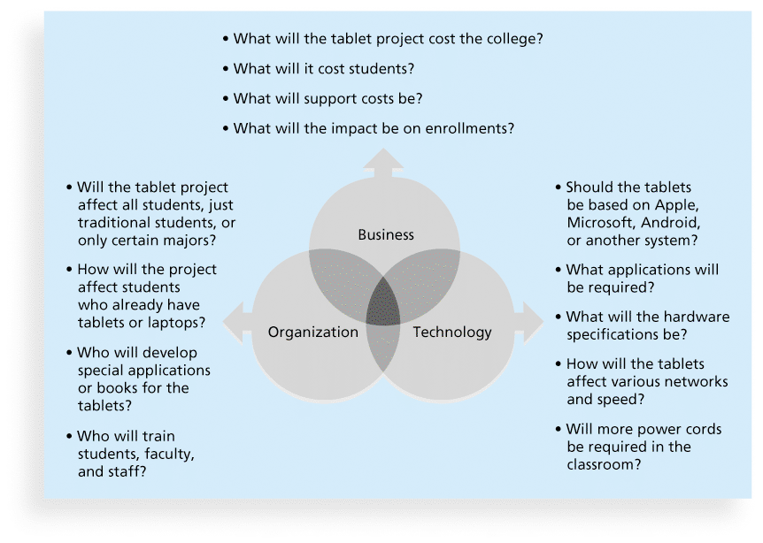
The three spheres overlap, which is crucial. When a project manager makes a decision that only considers one sphere, problems often arise in the others. For example, a purely technical decision (adopting a new software platform) may reduce costs (business) but create significant resistance from employees (organizational).

2.5 Real-Life Example: Systems Thinking in Action
EXAMPLE | A hospital decides to implement a new electronic health records (EHR) system. A project manager using systems thinking would consider: (1) Business: What is the ROI? Are there regulatory requirements? (2) Technology: Does the new system integrate with existing databases? (3) Organization: How will nurses and doctors need to change their workflows? Without all three, the implementation will likely fail — and many EHR projects have.

Chapter 3: Understanding Organizations
To manage IT projects effectively, you must understand how organizations work. Organizations are complex social systems, and their structure, culture, and internal politics profoundly affect project outcomes.

3.1 The Four Frames of Organizations
Organizational theorists Bolman and Deal identified four distinct "frames" or lenses through which an organization can be understood. Each frame reveals a different aspect of organizational life. A skilled project manager uses all four frames to navigate the organization.

Frame | Core Focus | Key Question | PM Application
Structural | Roles, responsibilities, rules, and hierarchies | Is the organization well-designed for the work? | Define clear roles and reporting structures
Human Resources | People's needs, skills, and relationships | Are people supported and motivated? | Build team morale and address conflicts
Political | Power, influence, and competing interests | Who has power and how is it used? | Manage stakeholder politics diplomatically
Symbolic | Culture, values, rituals, and stories | What does work mean to people here? | Align project goals with organizational values

No single frame gives a complete picture. The most effective project managers shift between all four frames depending on the situation. For example, when dealing with a resource conflict, they might use the political frame. When motivating a struggling team member, they shift to the human resources frame.

3.2 Organizational Structures
The formal structure of an organization — how it is organized — has a direct and significant impact on how projects are managed. There are three basic organizational structures:

3.2.1 Functional Structure
In a functional organization, employees are grouped by their area of specialization (e.g., Finance, IT, Marketing, Operations). Each department has its own manager, and projects must work within or across these functional silos.

- Project managers have limited authority
- Resources are controlled by functional managers
- Projects often struggle to get priority attention
- Works best for routine, department-specific work

3.2.2 Project Structure (Projectized)
In a projectized organization, teams are organized around projects. Project managers have full authority over their team, and resources are dedicated to the project.

- Project managers have high authority and control
- Team members work full-time on the project
- Clear accountability and focus
- Can be costly — resources may be idle between projects

3.2.3 Matrix Structure
A matrix organization is a hybrid. Team members report to both a functional manager (for their area of expertise) and a project manager (for the current project). Matrix structures come in three varieties:

- Weak Matrix: Functional manager has more power; PM acts more as a coordinator
- Balanced Matrix: Power is shared between functional and project managers
- Strong Matrix: Project manager has more power; closer to a projectized structure

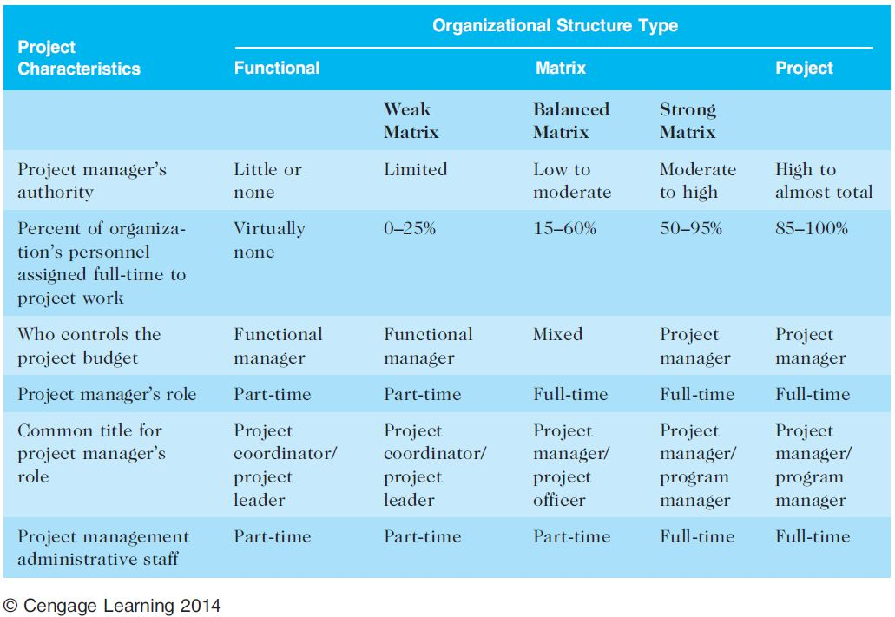

Structure Type | Best Used When...
Functional | Projects are routine and confined to one department
Weak Matrix | Most work is operational; projects are occasional add-ons
Balanced Matrix | Projects are important but the organization values functional expertise equally
Strong Matrix | Projects are critical and require cross-functional coordination
Projectized | The organization's primary output is projects (e.g., consulting firms, construction)

3.3 Organizational Culture
Organizational culture is the set of shared assumptions, values, and behaviors that characterize how an organization functions. Think of culture as the "personality" of an organization. It shapes how decisions are made, how people interact, and how problems are solved.

KEY INSIGHT | Culture is often invisible — but it is one of the most powerful forces in determining project success or failure. A project can have a perfect plan, but if it conflicts with the organizational culture, it will face serious resistance.

3.3.1 Key Characteristics of Organizational Culture
Researchers have identified ten key dimensions that describe organizational culture. The asterisked items (*) are particularly relevant to project management:

Cultural Characteristic | What It Means for Projects
Member Identity * | Do people identify with their job role or with the whole organization? Strong organizational identity supports cross-functional projects.
Group Emphasis * | Is work organized around individuals or teams? Team-oriented cultures make collaboration easier.
People Focus | How much does management consider the impact of decisions on employees? Higher people focus means more attention to team wellbeing.
Unit Integration * | How much do departments coordinate with each other? High integration supports large, cross-departmental IT projects.
Control | How many rules, policies, and supervision exist? Too much control slows projects; too little creates chaos.
Risk Tolerance * | How open is the organization to trying new ideas? IT projects often require innovation, so risk tolerance is critical.
Reward Criteria * | Are people rewarded for results, effort, seniority, or other factors? Reward systems shape behavior and team motivation.
Conflict Tolerance * | Is healthy disagreement encouraged or suppressed? High conflict tolerance leads to better decision-making.
Means-Ends Orientation | Does the organization focus more on outcomes (ends) or on following processes (means)?
Open-Systems Focus * | How aware is the organization of and responsive to its external environment?

Chapter 4: Case Study — What Went Wrong?
One of the most effective ways to learn about project management is to study real failures. The following case study is based on actual research on IT project failures in Europe.

4.1 The Study: A Pattern of IT Project Failure
WHAT WENT WRONG — Case Study
Study: "A Study in Project Failure" — European IT Projects
Duration: 8 years | Sample: 214 IT projects across multiple European countries

4.1.1 The Findings
Finding | Detail
Success Rate | Only 1 in 8 projects (12.5%) were considered fully successful in meeting scope, time, and cost goals
Primary Cause | Organizational culture was often to blame — not technology or technical skills
Key Issue #1 | People avoided discussing leadership challenges openly
Key Issue #2 | Stakeholder management issues were not raised or addressed
Key Issue #3 | Risk management concerns were minimized or ignored
Consequence | Projects ran over time, over budget, or failed to deliver expected scope

4.1.2 Lessons Learned
This study reveals several critical lessons that every IT project manager should internalize:

- Success is not just about technical execution — it is about organizational dynamics
- A culture that avoids difficult conversations about leadership will breed project failure
- Stakeholder relationships must be actively managed, not assumed to be fine
- Risk management must be treated as an ongoing conversation, not a one-time exercise
- Top management commitment is not optional — it is a prerequisite for success

4.2 The Broader Pattern: Industry-Wide Evidence
The European study is not an isolated finding. The Standish Group's Chaos Report, which tracks thousands of IT projects annually in the United States and globally, consistently finds similar patterns. Many IT projects are late, over budget, or deliver less than promised.

The good news: organizations that invest in project management practices, stakeholder engagement, and strong governance consistently achieve better results. This is not luck — it is the result of intentional, disciplined practice.

Chapter 5: Factors That Influence IT Project Success
Based on research and practice, six critical factors shape the success or failure of IT projects. Each must be understood and actively managed.

5.1 Overview of the Six Factors
Factor | Why It Matters
Organizational Structure | Determines authority, resource availability, and communication patterns for the project team
Organizational Culture | Shapes how people behave, make decisions, and respond to project demands
Top Management Commitment | Provides resources, removes obstacles, and signals organizational priority
Stakeholder Management | Ensures that all parties with an interest in the project are identified and engaged
Commitment to IT | Reflects the organization's overall attitude toward technology investment and capability
IT Governance / Standards | Provides frameworks and policies that guide IT decision-making consistently

5.2 Top Management Commitment
Of all the factors that influence IT project success, top management commitment is among the most powerful. Senior managers are not just project sponsors in name — they are active participants in creating the conditions for success.

5.2.1 How Top Management Helps Projects Succeed
- Providing adequate funding and resources when needed
- Removing organizational obstacles and bureaucratic barriers
- Resolving conflicts between departments or competing priorities
- Publicly communicating the importance and priority of the project
- Making timely decisions when project managers escalate issues
- Holding teams accountable for commitments and deliverables

5.3 Stakeholder Management
A stakeholder is anyone who has an interest in a project or who is affected by its outcomes. This includes team members, customers, executives, end users, vendors, regulators, and even the general public in some cases.

KEY POINT | The most important stakeholder is often the customer or the end user — the person who will ultimately use the product or service the project delivers. Failing to engage this person effectively is a leading cause of project failure.

5.3.1 The Four-Frame Approach to Stakeholder Management
The four organizational frames (structural, human resources, political, symbolic) are powerful tools for understanding different stakeholder needs:

- Structural Frame: Clarify stakeholder roles, authority, and responsibilities
- Human Resources Frame: Understand stakeholder personal goals, fears, and motivations
- Political Frame: Identify power dynamics and competing interests among stakeholders
- Symbolic Frame: Connect the project to values and stories that stakeholders care about

5.4 Organizational Commitment to IT
An organization's attitude toward information technology has a profound effect on IT project outcomes. If leadership views IT as a necessary cost rather than a strategic asset, IT projects will struggle to get attention, resources, and priority.

Positive IT Commitment Signals | Negative IT Commitment Signals
A Chief Information Officer (CIO) reports directly to the CEO | IT department reports to Finance as a cost center
Non-IT executives participate in IT project steering committees | IT projects are entirely owned and managed by the IT department
Senior leaders publicly champion IT initiatives | IT requests are frequently delayed or underfunded
IT is included in strategic planning discussions | IT projects are the first to be cut during budget reductions

5.5 IT Governance and Standards
IT governance refers to the framework of authority, accountability, and decision-making processes that guide how an organization manages its IT resources and activities. It covers three key areas:

- IT Infrastructure: Who decides what hardware, software, and networks the organization uses?
- IT Use: Who is accountable for how technology is applied across business units?
- Project Management: What standards and processes govern how IT projects are initiated and managed?

Practical tools for IT governance include:

- A Project Management Office (PMO) that sets and enforces project standards
- Standardized templates and forms for project charters, risk logs, and status reports
- Portfolio management processes to ensure the right projects get approved and funded
- Reference frameworks such as COBIT, ITIL, and PMBOK

EXAMPLE | Texas Tech University developed IT Project Management Standards to ensure that all university IT projects follow consistent processes for planning, execution, and reporting. This kind of institutional standard reduces chaos and improves outcomes across the portfolio.

Chapter 6: Project Phases and the Project Life Cycle

6.1 What Is a Project Life Cycle?
A project life cycle is the structured sequence of phases that a project passes through from its beginning to its end. The life cycle provides a framework for managing the project in an organized, predictable way.

KEY DEFINITION | Project Life Cycle: A collection of project phases that defines what work will be performed in each phase, what deliverables will be produced, who will be involved, and how management will control and approve the work.

6.2 What Is a Deliverable?
A deliverable is any product, service, or result that is produced as part of a project. Deliverables can be:

- Tangible: Software application, hardware system, user manual, database
- Intangible: Completed training program, process improvement, strategy document
- Intermediate: Design specification, prototype, test results (not final products but essential steps)

6.3 The Traditional Project Life Cycle Phases
The traditional project life cycle follows four sequential phases. Each phase builds on the previous one and produces specific outputs needed for the next phase.

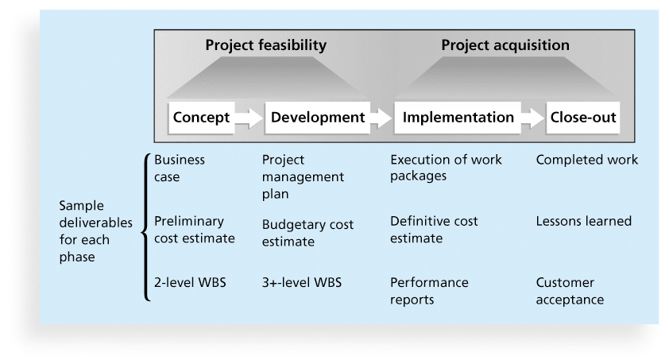
Phase | Core Activities | Key Deliverables | Key Questions Answered
1. Concept | Identify the need; define the problem; assess feasibility | Business case, feasibility study, initial scope statement | Should we do this project at all?
2. Development | Detailed planning: schedule, budget, resources, risk management | Project plan, work breakdown structure, resource plan | How exactly will we do this project?
3. Implementation | Execute the plan; build the product; manage issues and changes | Working product or service, progress reports, change requests | Are we doing the project right?
4. Close-out | Final delivery; lessons learned; team release; administrative closure | Final report, acceptance sign-off, lessons learned document | Did we complete everything and are all stakeholders satisfied?

6.4 Management Reviews: Phase Gates and Kill Points
At the end of each project phase, a management review — also called a phase gate, phase exit, or kill point — should occur. This is a formal checkpoint where senior management evaluates the project before approving it to continue to the next phase.

6.4.1 What Is Evaluated at a Phase Gate?
- Has the project achieved the expected outcomes for this phase?
- Is the project still on track in terms of schedule, budget, and scope?
- Do the expected benefits still justify the remaining investment?
- Are there any new risks or changed circumstances that affect the project?
- Is the project still aligned with current organizational strategy and goals?

6.4.2 Possible Outcomes of a Phase Gate Review
Outcome | Description
Approve and Continue | The project passes the gate and proceeds to the next phase as planned
Approve with Conditions | The project may continue but must address specific issues or changes
Pause / Hold | The project is suspended while key issues are resolved
Redirect | The project continues but with a significantly changed scope, budget, or approach
Terminate (Kill Point) | The project is cancelled — it is no longer viable or aligned with business needs

KEY INSIGHT | The ability to stop a failing project — to "get off a dead horse" before it costs even more — is one of the most valuable capabilities in IT project management. Many organizations historically continued failing projects far too long, leading to enormous waste.

6.5 Project Life Cycle vs. Product Life Cycle
It is important to distinguish between the project life cycle and the product life cycle. These are related but different concepts:

Concept | Description
Project Life Cycle | The phases a project goes through from initiation to closure. Ends when the project is complete.
Product Life Cycle | The entire life of a product, from initial conception through eventual retirement. Continues long after the project ends.
Relationship | A project creates or modifies a product. The product then lives on independently, often requiring future projects for maintenance and enhancement.

Chapter 7: Systems Development Life Cycles and Development Models

7.1 What Is the Systems Development Life Cycle (SDLC)?
The Systems Development Life Cycle (SDLC) is a framework that describes the phases involved in developing and maintaining information systems. While the project life cycle applies to all types of projects, the SDLC is specific to software and technology systems development.

There are two major families of SDLC approaches, each suited to different types of projects and organizational cultures:

- Predictive Life Cycle: The full scope is planned upfront; requirements are fixed before development begins
- Adaptive Life Cycle: The project scope evolves through short cycles of planning, building, and feedback

7.2 Predictive Life Cycle Models
Predictive models assume that the project requirements are well understood from the beginning and will not change significantly during development. They favor thorough upfront planning.

Model | Description and Best Use
Waterfall Model | Sequential phases (Requirements > Design > Code > Test > Deploy). Best for well-defined, stable requirements. Changes are costly once a phase is complete.
Spiral Model | Combines iterative development with risk management. Each spiral cycle includes planning, risk analysis, engineering, and evaluation. Best for large, complex, high-risk projects.
Incremental Build Model | Delivers the system in increments, each adding more functionality. Core functionality is delivered first; additional features are added in successive releases.
Prototyping Model | Builds a preliminary version (prototype) of the system quickly to gather user feedback. The prototype is refined based on feedback until the final system emerges.
Rapid Application Development (RAD) | Emphasizes speed and user involvement. Uses prototyping and iterative development to deliver systems quickly, often in 60-90 day cycles.

7.3 Agile Software Development
Agile is a family of software development approaches that has become increasingly popular since the early 2000s. Agile methods were created in response to the limitations of rigid, plan-heavy approaches that struggled to adapt to changing business needs.

KEY DEFINITION | Agile: An iterative, incremental approach to software development that emphasizes close collaboration between development teams and business stakeholders, with continuous feedback and adaptive planning.

7.3.1 Core Principles of Agile Development
- Working software is the primary measure of progress — not documentation
- Respond to change rather than following a fixed plan
- Customer collaboration over contract negotiation
- Short development cycles (sprints) of 1-4 weeks
- Continuous testing and integration throughout development
- Self-organizing, cross-functional teams

7.3.2 Predictive vs. Agile: Comparison
Predictive (Waterfall) | Agile
Requirements defined fully upfront | Requirements evolve throughout the project
Long planning phase before development begins | Planning is continuous and iterative
Changes are controlled and costly | Changes are welcomed and expected
Customer sees the product at the end | Customer sees working software every 1-4 weeks
Best for stable, well-defined requirements | Best for complex or rapidly changing requirements
Formal, documented processes | Face-to-face communication and collaboration preferred
One large delivery at end of project | Multiple small deliveries throughout the project

Chapter 8: What Went Right — Success Insights

8.1 Learning to Stop a Failing Project
WHAT WENT RIGHT — Success Story
Organization: Huntington Bancshares, Inc.
Challenge: Continuing to invest in failing projects too long
Solution: Implemented an Executive Steering Committee for project oversight

8.2 The Thomas Edison Lesson
Jim Johnson of the Standish Group described the key improvement in IT project management using a powerful analogy from Thomas Edison:

Edison's key to success was not that he never failed — he failed frequently. His true genius was that he could recognize when an approach was not working early enough to abandon it and try something new. He knew "when to stop beating a dead horse."

In IT, the equivalent is recognizing when a project is failing and having the organizational courage to stop it. For decades, IT organizations continued pouring money and resources into obviously failing projects because of sunk cost thinking, political pressure, or lack of proper review processes.

The Problem (Before) | The Improvement (After Phase Gates)
Projects ran far over budget and schedule with no clear decision point | Formal phase gates create mandatory decision points for management review
Teams felt obligated to continue because of prior investment | Management evaluates future value, not past cost
IT failures were discovered only at the very end, maximizing damage | Early warning signs are caught at phase gates and acted upon
Project managers avoided escalating bad news | Governance structures create safe channels for honest reporting

Chapter 9: The Unique Context of IT Projects

9.1 Why IT Projects Are Different
Information technology projects have characteristics that make them uniquely challenging compared to projects in other fields such as construction, manufacturing, or finance. Understanding these differences is essential for any IT project manager.

9.1.1 Diversity in Size and Complexity
IT projects range from a simple website update taking two days to massive enterprise system implementations spanning years and costing hundreds of millions of dollars. This enormous range of scale means that what works for a small project may be completely inappropriate for a large one.

9.1.2 Diversity in Team Members
IT project teams are typically composed of people with very different backgrounds, skills, and perspectives:

- Software developers and engineers who think in systems and code
- Business analysts who bridge technical and business requirements
- Project managers who coordinate people and plans
- End users who understand the problem but not the technology
- Executives who focus on business value and strategic alignment

Managing these diverse perspectives requires exceptional communication, facilitation, and leadership skills from the project manager.

9.1.3 Diversity in Technology
IT projects involve rapidly evolving technologies. A technology that was cutting-edge at the start of a project may be outdated by the time the project ends. This technological volatility creates unique risks:

- Requirements may change as new technology possibilities emerge
- Technical skills may need to be acquired mid-project
- Integration with existing legacy systems is often complex and underestimated
- Security and compliance requirements evolve continuously

9.2 Strategies for Improving IT Project Success
Given these challenges, what approaches consistently improve IT project outcomes? Research and practice point to four key strategies:

Strategy | Description and Key Actions
Value-Driven Approach | Focus every decision on delivering measurable business value. Regularly ask: how does this activity contribute to the business outcome we are trying to achieve?
Socio-Technical Approach | Recognize that IT systems affect people and work processes. Design both the technical system and the human/organizational system together, not separately.
Project Management Principles (Chaos Report) | Apply proven PM practices: clear goals, executive sponsor, user involvement, iterative development, and competent project managers.
Knowledge Management Approach | Capture and share lessons learned from both successes and failures. Build organizational memory so that each project learns from all previous projects.

Chapter 10: Modern Trends Affecting IT Project Management
The world of IT project management is changing rapidly. Several major trends are transforming how IT projects are structured, staffed, and executed. Every IT project manager must understand and adapt to these trends.

10.1 Globalization
Globalization means that IT projects are increasingly designed, developed, and delivered by teams that span multiple countries and time zones. This creates enormous opportunities — and significant challenges.

Globalization Issues | Recommended Solutions
Communication barriers across languages and cultures | Establish clear communication protocols; use translators where needed; document everything
Building trust across distance and cultural differences | Invest in relationship-building; schedule in-person meetings for project launch and key milestones
Inconsistent work practices across teams | Define and enforce common project management standards across all locations
Tool fragmentation (different tools in different locations) | Standardize on shared collaboration, project management, and communication tools
Time zone coordination difficulties | Create overlapping work hours for essential meetings; rotate inconvenient time slots fairly

KEY PRINCIPLE | Think global, act local. Global IT projects benefit from standardized processes and tools across locations, while also respecting and adapting to local cultural practices, regulations, and working styles.

10.2 Outsourcing
Outsourcing involves contracting parts of a project or business function to an external organization. IT outsourcing has been a major trend for decades, with organizations outsourcing software development, infrastructure management, help desk support, and more.

10.2.1 Why Organizations Outsource IT
- Cost reduction: Labor costs are typically lower in offshore locations
- Access to specialized skills not available internally
- Ability to scale resources up or down quickly
- Focus on core business activities while a vendor handles non-core IT functions

10.2.2 The Strategic Challenge of Outsourcing
Simply outsourcing to cut costs is no longer sufficient for competitive advantage. Organizations must make strategic IT investments with outsourcing by ensuring that IT infrastructure and business processes are integrated and standardized across the enterprise. The key question is: which IT capabilities must remain internal (core) and which can be outsourced (non-core)?

10.3 Virtual Teams
A virtual team is a group of people who work together on a common project but are dispersed geographically and collaborate primarily through technology — email, video conferencing, project management tools, and instant messaging.

Advantages of Virtual Teams | Disadvantages of Virtual Teams
Access to talent worldwide without geographic constraints | Social isolation and lack of personal connection among team members
Lower costs (no need for co-location, reduced real estate) | Communication problems due to distance, time zones, and cultural differences
Greater scheduling flexibility and work-life balance options | Heavy dependence on technology — technical failures disrupt work
Ability to form teams quickly from available talent | Difficulty building trust without face-to-face interaction
Increased responsiveness to global customer needs | Harder to detect and resolve interpersonal conflicts early

10.4 Agile and Extreme Project Management
Traditional project management assumes that projects can be fully planned upfront and executed according to plan. Modern approaches recognize that many IT projects — especially software development — are inherently complex, uncertain, and changing.

10.4.1 eXtreme Project Management (XPM)
- Takes a holistic view of planning and managing complex projects
- Recognizes that projects do not always fit traditional scheduling and formal techniques
- Acknowledges the inherently chaotic nature of many IT projects
- Focuses heavily on the human side of project management: team dynamics, motivation, and adaptive leadership

10.4.2 Agile Project Management
- Uses an iterative, incremental approach to deliver value continuously
- Popular across the IT industry, with certifications available from PMI (PMI-ACP) and Scrum Alliance
- Works in short cycles (sprints) with regular customer feedback and adaptation
- Requires organizational culture that supports collaboration, transparency, and change tolerance

Chapter 11: Chapter Summary

11.1 What We Covered
This chapter introduced the critical context in which IT project management takes place. We moved from foundational concepts through organizational theory, life cycle management, and modern trends. Here is a concise summary of each major area:

Topic Area | Summary
Systems View of PM | Projects are part of larger organizational systems. Systems philosophy, analysis, and management — including the Three Sphere Model — help PMs see the big picture.
Four Organizational Frames | Structural, human resources, political, and symbolic frames provide different lenses for understanding organizational behavior and stakeholder needs.
Organizational Structures | Functional, matrix (weak/balanced/strong), and projectized structures differ significantly in how much authority a project manager has.
Organizational Culture | Culture shapes behavior more than formal policies. Ten dimensions of culture affect how projects are received and managed.
Top Management Commitment | Executive support is critical. PMs need active sponsorship, not just theoretical approval.
Stakeholder Management | All parties with an interest in the project must be identified and actively engaged throughout the project.
IT Governance | Standards, PMOs, and governance frameworks create the institutional environment for consistent IT project success.
Project Life Cycle | Projects move through phases: Concept, Development, Implementation, Close-out. Phase gates enable informed Go/No-Go decisions.
SDLC Models | Predictive models (Waterfall, Spiral, RAD) and adaptive models (Agile) serve different project needs.
Modern Trends | Globalization, outsourcing, virtual teams, and agile project management are reshaping how IT projects are staffed and delivered.

Key Takeaways
- Projects do not exist in isolation — they are embedded in organizational systems that must be understood and managed.
- The four organizational frames (structural, HR, political, symbolic) help PMs navigate complex organizations and meet diverse stakeholder needs.
- Organizational structure directly affects a project manager's authority — functional structures limit it; projectized structures maximize it.
- Organizational culture is one of the most powerful predictors of IT project success or failure.
- Top management commitment is not optional — it is a prerequisite for IT project success.
- Phase gates (kill points) are critical governance mechanisms that prevent organizations from continuing to invest in failing projects.
- The traditional project life cycle (Concept > Development > Implementation > Close-out) provides structure, while agile approaches offer flexibility for uncertain environments.
- Globalization, outsourcing, and virtual teams require new skills in cross-cultural communication, vendor management, and distributed team leadership.
- The key to improving IT project success is a combination of sound methodology, strong leadership, stakeholder engagement, and organizational learning.

Appendix A: Discussion Questions and Reflection Activities
Use these questions to test your understanding of the chapter content and to apply concepts to real-world situations.

A.1 Conceptual Understanding Questions
- In your own words, explain the Three Sphere Model. Why is it important to consider all three spheres simultaneously when making project decisions?
- Compare and contrast the three organizational structures (functional, matrix, projectized). Under what circumstances would each structure be most appropriate for managing IT projects?
- Why is organizational culture often cited as a root cause of IT project failure? Give an example of how a specific cultural characteristic (e.g., low risk tolerance) could negatively affect an IT project.
- What is the difference between a project life cycle and a product life cycle? Give a concrete example of each using a real IT product.
- What is an agile approach to project management, and in what types of projects is it most appropriate? How does it differ from the traditional waterfall model?

A.2 Application and Critical Thinking Questions
- Given what you have learned in this chapter, do you believe IT projects are harder to manage than traditional projects (e.g., construction, manufacturing)? Justify your answer with specific examples.
- If you were managing a large IT project with stakeholders across five departments, which organizational frame(s) would you use most frequently, and why?
- A major IT project in your organization has been running for 18 months and is now 40% over budget with no end in sight. Using the concept of phase gates and kill points, what should management do? What organizational barriers might make it difficult to make the right decision?
- Your organization is planning to outsource a major software development project to a team in another country. What are the top three risks you would identify, and what strategies would you use to mitigate them?

Appendix B: Glossary of Key Terms
Term | Definition
Agile | An iterative, incremental approach to software development emphasizing collaboration, flexibility, and continuous delivery of working software.
Deliverable | Any product, service, or result produced as part of a project phase or the project as a whole.
Executive Steering Committee | A group of senior executives responsible for providing oversight, direction, and support to major projects.
Functional Structure | An organizational structure where employees are grouped by functional area (e.g., IT, Finance, Marketing).
IT Governance | The framework of authority, accountability, and decision-making processes that guide how an organization manages its IT activities.
Kill Point | A phase gate decision point where management may choose to terminate a project that is no longer viable or aligned with organizational goals.
Matrix Structure | An organizational structure combining functional and project-based reporting, where employees report to both a functional manager and a project manager.
Organizational Culture | The shared values, assumptions, and behaviors that characterize how an organization operates and how people interact.
Phase Gate | A formal review at the end of a project phase, where management decides whether to continue, redirect, or terminate the project.
Product Life Cycle | The entire lifespan of a product, from initial conception through eventual retirement or replacement.
Project Life Cycle | The collection of phases a project passes through from initiation to closure.
Projectized Structure | An organizational structure where resources are organized primarily around projects, and project managers have full authority over their teams.
SDLC | Systems Development Life Cycle — a framework describing the phases involved in developing and maintaining information systems.
Stakeholder | Any individual or group who has an interest in a project or is affected by its outcomes.
Systems Thinking | An approach that views a project as part of a larger interconnected system, considering all related components and their interactions.
Three Sphere Model | A framework that requires project decisions to consider three dimensions simultaneously: business, technology, and organization.
Virtual Team | A team whose members are geographically dispersed and collaborate primarily through technology.
Waterfall Model | A sequential software development model where each phase must be completed before the next begins.
XPM | eXtreme Project Management — an approach for managing complex, chaotic projects with a strong focus on the human side of PM.

